Ansible Challenge
Create ci pipeline that will deploy and configure these VMs using terraform and ansible according following requirements
- Deploy 2 virtual machines using terraform.
  - first vm on Amazon linux, hostname: c8.local
  - second vm on ubuntu 21.04, hostname: u21.local
- As a result of terraform execution, dynamically create inventory for ansible
  - c8.local should be in the frontend group
  - u21.local should be in the backend group
- Create ansible playbook for c8.local and u21.local
- for linux OS playbook should apply the following changes
  - selinux: disable
  - firewalld: disable
- for frontend playbook group should install and configure nginx
  - nginx configuration should do proxying from port 80 on port 19999 to the
  - backend group
- for the backend group, the playbook must install the Netdata application from the
  - official repositories and run it on port 19999.

🔵 STEP – Prerequisites (DO THIS ON JENKINS / CONTROL NODE)
Required tools
terraform --version
ansible --version
git --version
aws --version
java -version # for Jenkins
AWS
- IAM user with EC2 permissions
- Access key & secret key
- SSH key pair (devops.pem)
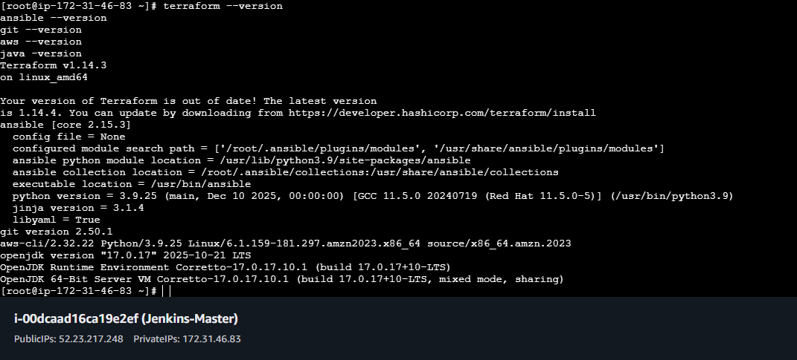

STEP 1 – Project Structure (VERY IMPORTANT)
Create project directory:
mkdir devops-ci-challenge
cd devops-ci-challenge
Final structure:
devops-ci-challenge/
├── terraform/
│ ├── main.tf
│ ├── variables.tf
│ ├── outputs.tf
│ └── inventory.tpl
├── ansible/
│ ├── site.yml
│ └── roles/
│ ├── common/
│ ├── frontend/
│ └── backend/
└── Jenkinsfile
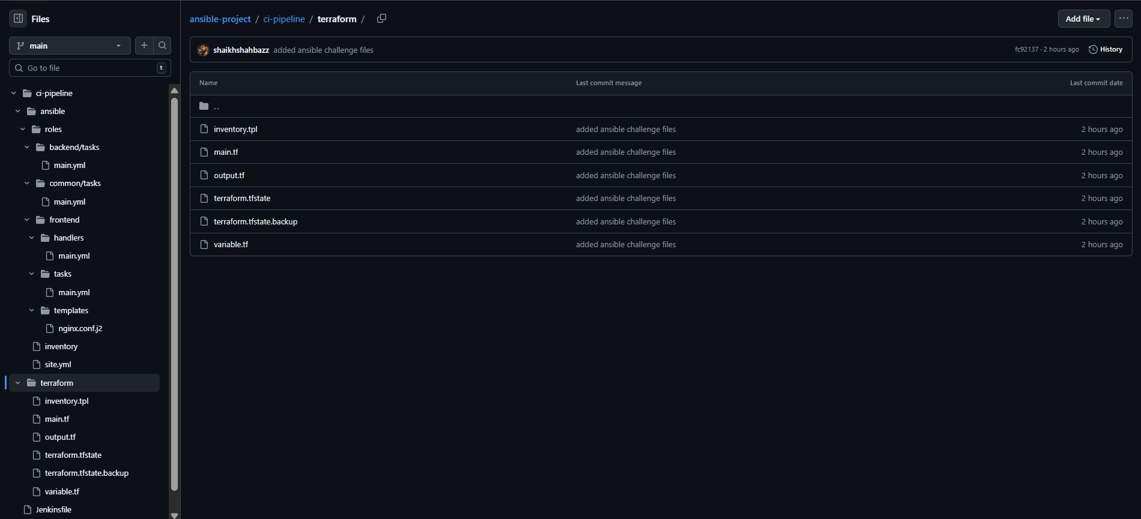
STEP 2 – Terraform (Infrastructure Creation)
Terraform Responsibility
- Create 2 EC2 instances
- Assign hostnames
- Generate Ansible inventory dynamically

2.1 Terraform Variables
terraform/variables.tf
variable "region" {
default = "us-east-1"
}

variable "key_name" {
default = "devops"
}
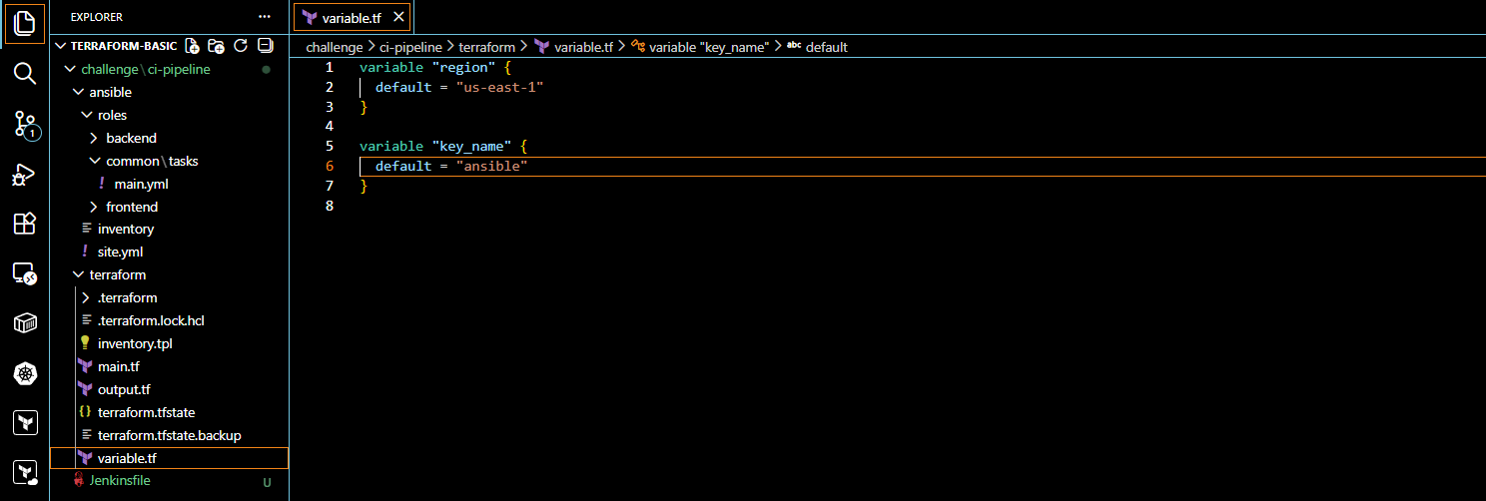

2.2 Terraform Main Configuration
terraform/main.tf
provider "aws" {
region = var.region
}

resource "aws_instance" "frontend" {
ami = "ami-0c02fb55956c7d316" # Amazon Linux 2
instance_type = "t2.micro"
key_name = var.key_name

tags = {
Name = "c8.local"
}
}

resource "aws_instance" "backend" {
ami = "ami-08c40ec9ead489470" # Ubuntu 21.04
instance_type = "t2.micro"
key_name = var.key_name

tags = {
Name = "u21.local"
}
}
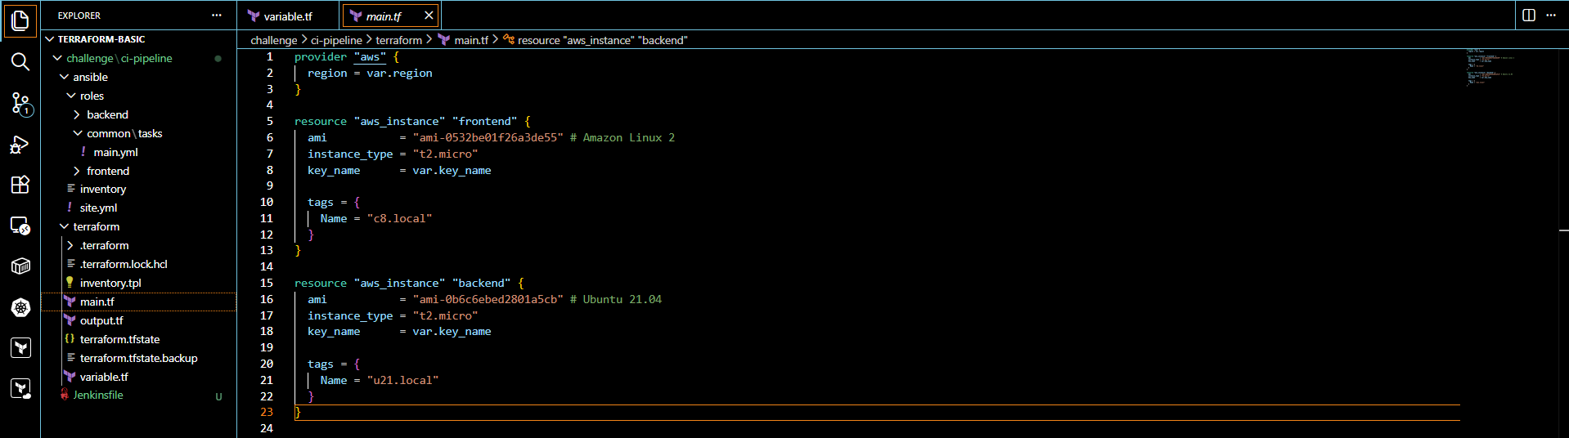
2.3 Dynamic Inventory Template
terraform/inventory.tpl
[frontend]
c8.local ansible_host=${frontend_ip} ansible_user=ec2-user

[backend]
u21.local ansible_host=${backend_ip} ansible_user=ubuntu
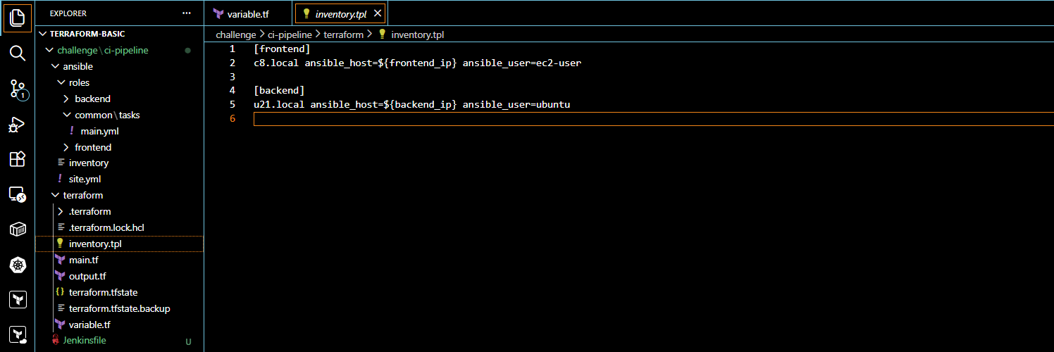
2.4 Terraform Outputs + Inventory Generation
terraform/outputs.tf
resource "local_file" "ansible_inventory" {
content = templatefile("${path.module}/inventory.tpl", {
frontend_ip = aws_instance.frontend.public_ip
backend_ip = aws_instance.backend.public_ip
})

filename = "${path.module}/../ansible/inventory"
}
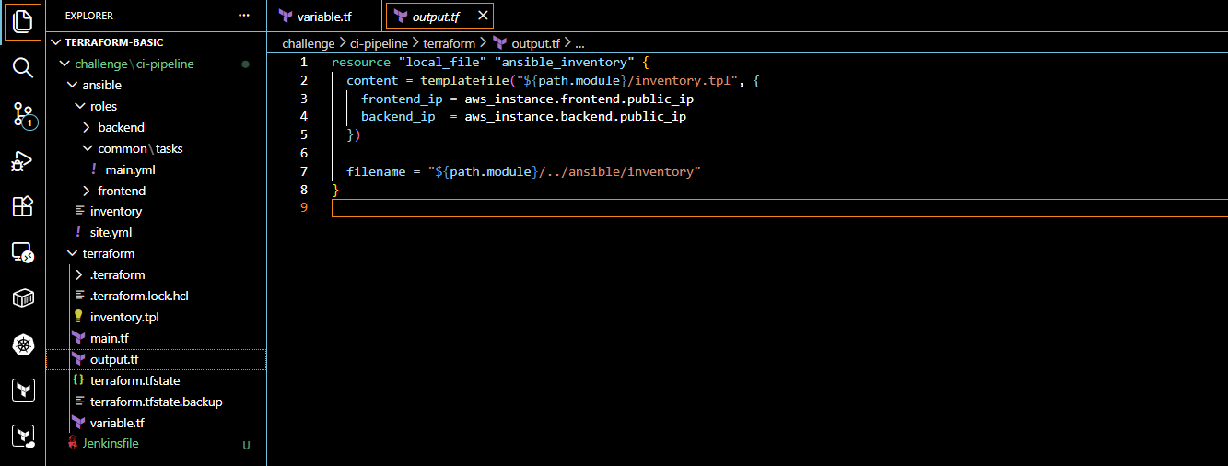
2.5 Run Terraform (Manual Test)
cd terraform
terraform init
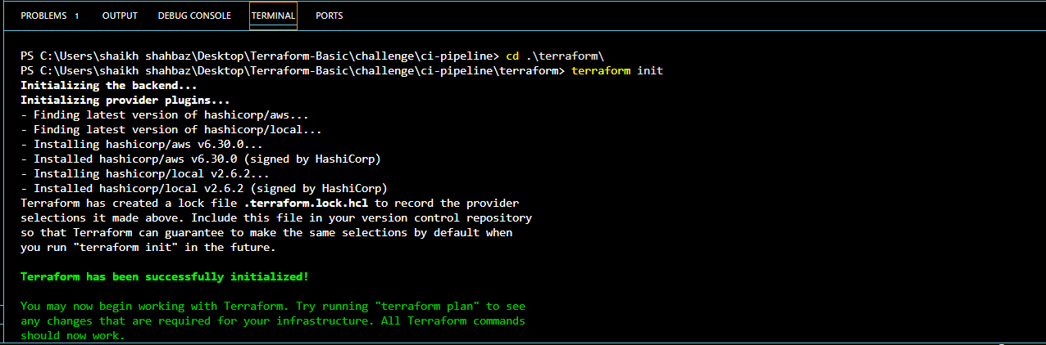
terraform apply -auto-approve
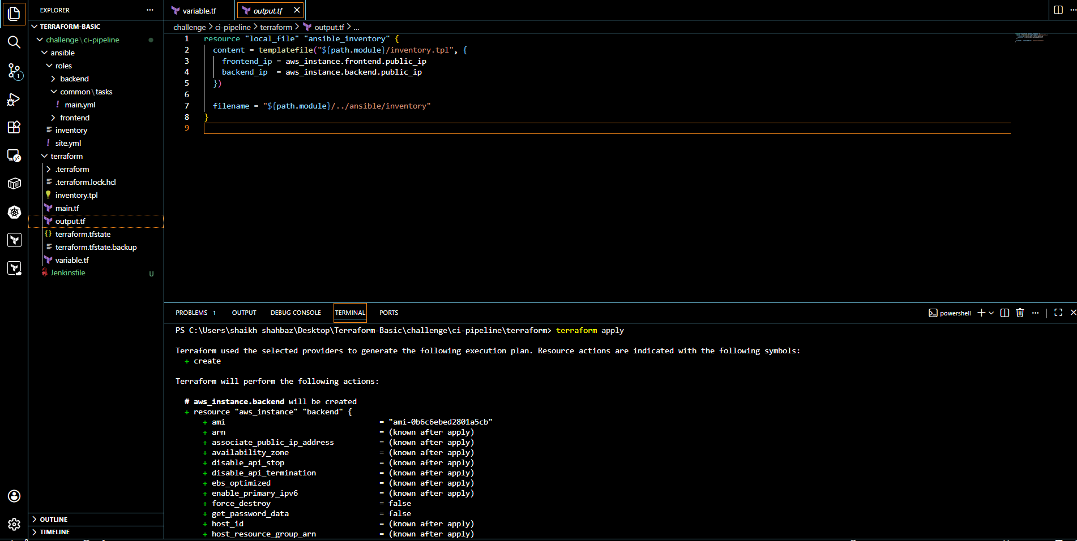
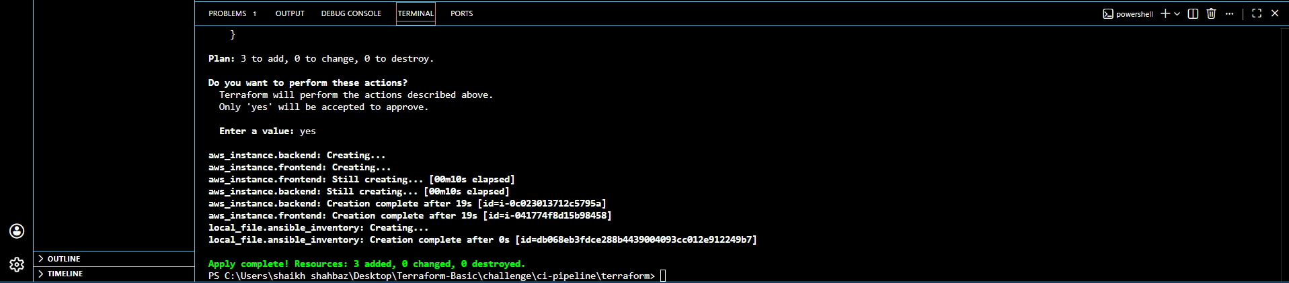
✔ EC2s created
✔ ansible/inventory generated automatically
Validation:
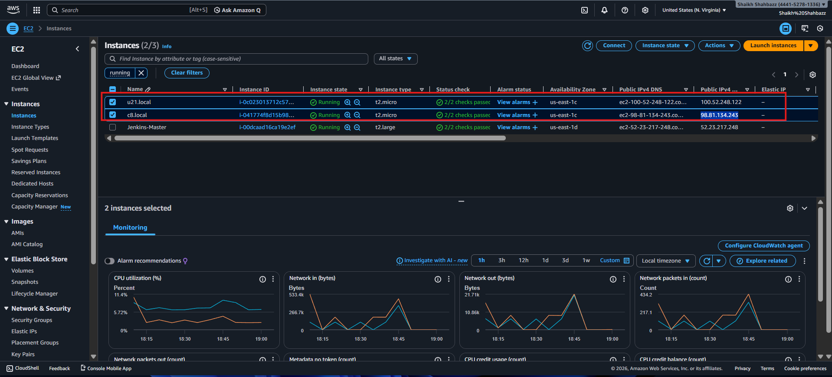
STEP 3 – Ansible Configuration (ROLES BASED)
3.1 Create Roles Using Galaxy
cd ../ansible
ansible-galaxy init roles/common
ansible-galaxy init roles/frontend
ansible-galaxy init roles/backend
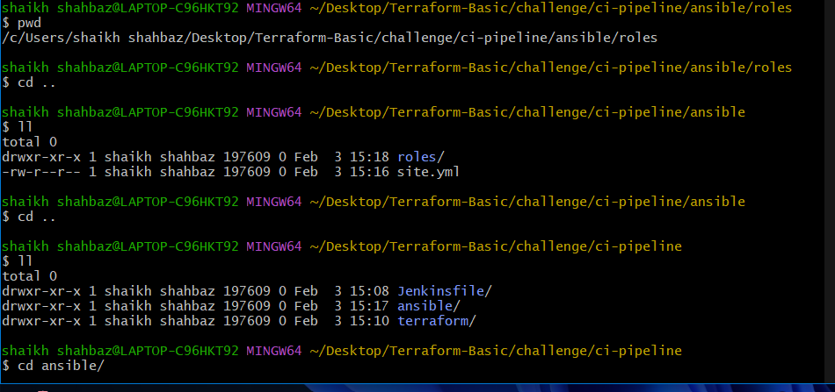
STEP 4 – Common Role (All Hosts)
Purpose
- Disable SELinux
- Disable Firewall
roles/common/tasks/main.yml
- name: Disable SELinux
selinux:
state: disabled
when: ansible_os_family == "RedHat"

- name: Stop firewalld
service:
name: firewalld
state: stopped
enabled: false
when: ansible_os_family == "RedHat"

- name: Stop UFW
service:
name: ufw
state: stopped
enabled: false
when: ansible_os_family == "Debian"
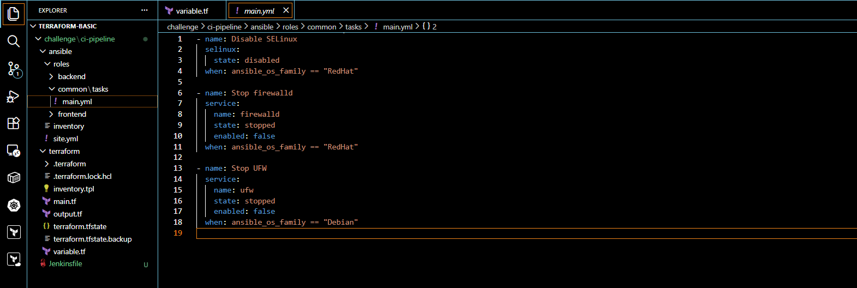
STEP 5 – Frontend Role (NGINX Reverse Proxy)
Purpose
- Install nginx
- Proxy port 80 → backend:19999

roles/frontend/tasks/main.yml
- name: Install Nginx
package:
name: nginx
state: present

- name: Configure Nginx reverse proxy
template:
src: nginx.conf.j2
dest: /etc/nginx/nginx.conf

- name: Start Nginx
service:
name: nginx
state: started
enabled: yes
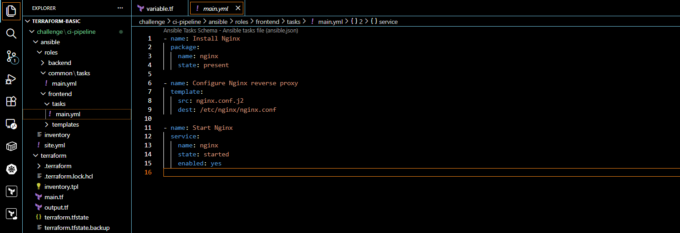
roles/frontend/templates/nginx.conf.j2
events {}

http {
server {
listen 80;

location / {
proxy_pass http://{{ groups['backend'][0] }}:19999;
}
}
}
✔ Uses Ansible group dynamically
✔ No hardcoded IPs
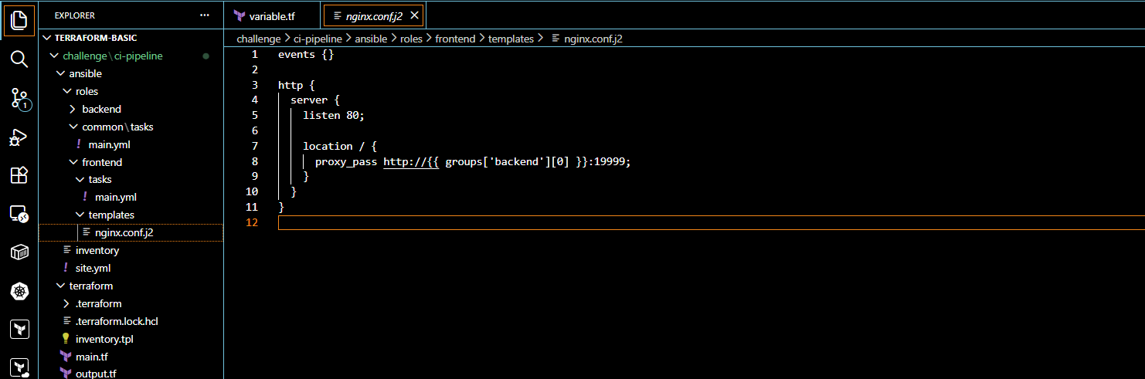
STEP 6 – Backend Role (NETDATA)
roles/backend/tasks/main.yml
- name: Install Netdata
shell: curl -s https://my-netdata.io/kickstart.sh | bash
args:
creates: /usr/sbin/netdata

- name: Ensure Netdata running
service:
name: netdata
state: started
enabled: yes
✔ Runs on port 19999 by default
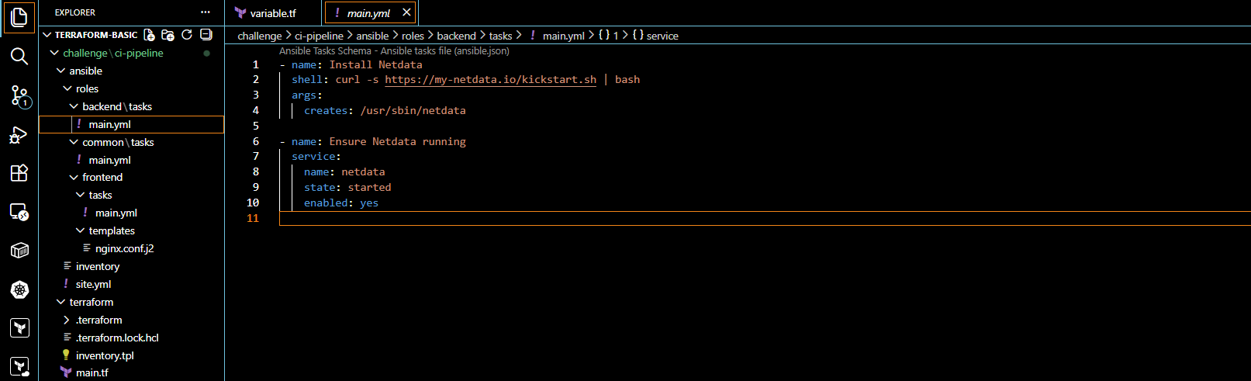
STEP 7 – Main Ansible Playbook
ansible/site.yml
---
- hosts: all
become: yes
roles:
- common

- hosts: frontend
become: yes
roles:
- frontend

- hosts: backend
become: yes
roles:
- backend
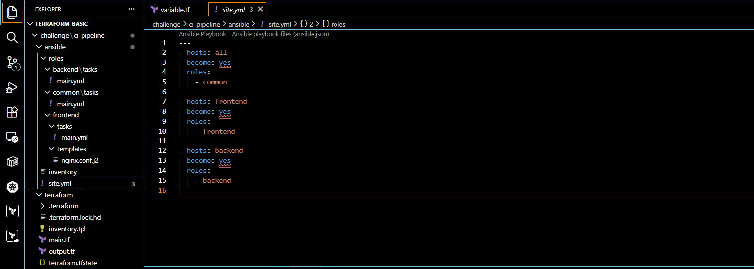

STEP 8 – Jenkins CI Pipeline

Jenkins Role
- Orchestrate Terraform
- Run Ansible automatically
- Zero manual steps

Jenkinsfile
pipeline {
agent any

environment {
AWS_DEFAULT_REGION = "us-east-1"
}

stages {

stage('Checkout') {
steps {
git url: 'https://github.com/shaikhshahbazz/ansible-project.git',
branch: 'main'
}
}

stage('Terraform Init') {
steps {
dir('ci-pipeline/terraform') {
sh 'terraform init'
}
}
}

stage('Terraform Apply') {
steps {
withCredentials([
string(credentialsId: 'AWS_ACCESS_KEY_ID', variable: 'AWS_ACCESS_KEY_ID'),
string(credentialsId: 'AWS_SECRET_ACCESS_KEY', variable: 'AWS_SECRET_ACCESS_KEY')
]) {
dir('ci-pipeline/terraform') {
sh '''
terraform apply -auto-approve
'''
}
}
}
}

stage('Ansible Configure') {
steps {
withCredentials([
sshUserPrivateKey(
credentialsId: 'ssh-private-key',
keyFileVariable: 'SSH_KEY',
usernameVariable: 'SSH_USER'
)
]) {
dir('ci-pipeline/ansible') {
script {
// Fetch backend IP safely from Terraform output
def backend_ip = sh(
script: "terraform -chdir=../terraform output -raw backend_ip || echo ''",
returnStdout: true
).trim()

if (!backend_ip) {
error "❌ Terraform output 'backend_ip' not found! Make sure it's defined in Terraform."
} else {
echo "✅ Backend IP found: ${backend_ip}"
}

sh """
chmod 600 \$SSH_KEY
export ANSIBLE_HOST_KEY_CHECKING=False

ansible-playbook \
-i inventory \
site.yml \
--user=\$SSH_USER \
--private-key=\$SSH_KEY \
--extra-vars "backend_ip=${backend_ip}"
"""
}
}
}
}
}
}

post {
success {
echo '🎉 Pipeline completed successfully without errors!'
}
failure {
echo '❌ Pipeline failed. Check logs above.'
}
}
}

STEP 9 – Jenkins Credentials (IMPORTANT)
In Jenkins:
- Store AWS credentials
- Store SSH private key
- Use environment variables (best practice)

STEP 10 – FINAL VALIDATION
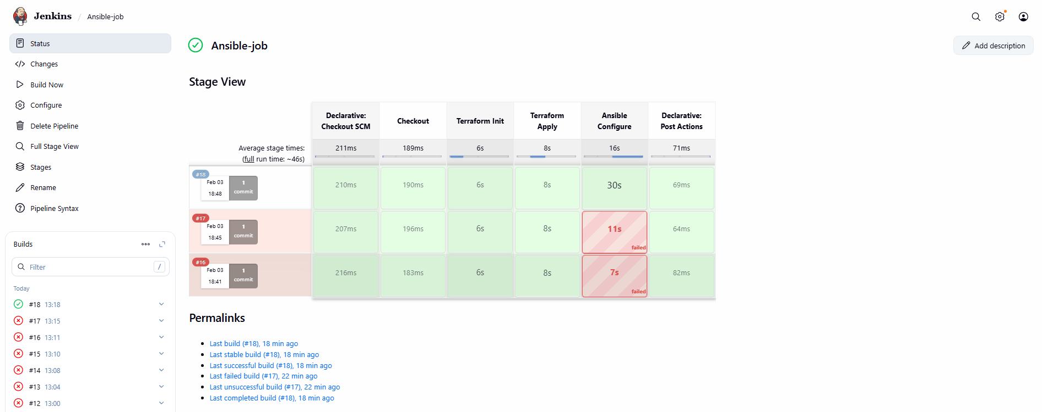
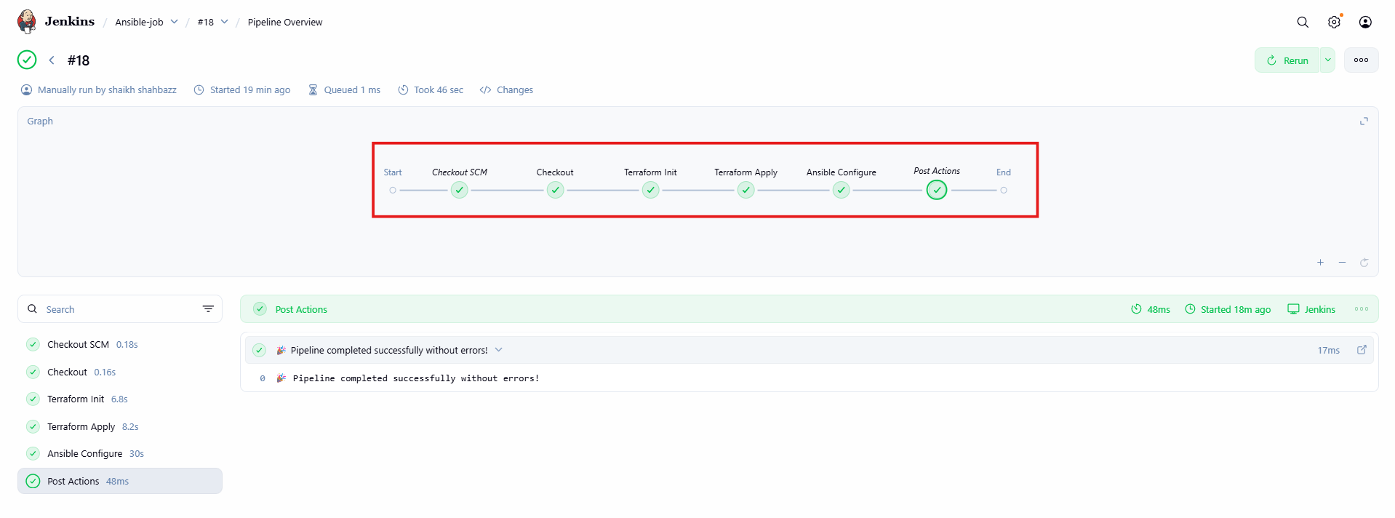
Access:
http://<frontend-public-ip>
✔ Nginx responds
✔ Netdata UI loads
✔ Proxy works
